SMIT R PATEL

19162121031

SEM 5

PRACTICAL 13

HIVE

BIG DATA AND ANALYTICS

AIM- To work with Hive in Hadoop.

Exercise: You work as a data analyst for a bank, which now needs you to analyse a few things mentioned below in order to launch a new scheme.

Tasks:

1. Create Table for the Bank Dataset using following columns:

1 - age (numeric)

2 - job: type of job

("admin.","unknown","unemployed","management","housemaid","entrepreneur","student", "blue-collar","self-employed","retired","technician","services")

3 - marital : marital status ("married","divorced","single"; note: "divorced" means divorced or widowed)

4 - education ( "unknown","secondary","primary","tertiary")

5 - default: has credit in default? ("yes","no")

6 - balance: average yearly balance, in euros (numeric)

7 - housing: has housing loan? ("yes","no")

8 - loan: has personal loan? ("yes","no")

9 - contact: contact communication type ("unknown","telephone","cellular")

10 - day: last contact day of the month (numeric)

11 - month: last contact month of year "jan", "feb", "mar", ..., "nov", "dec")

12 - duration: last contact duration, in seconds (numeric)

13 - campaign: number of contacts performed during this campaign and for this client (numeric, includes last contact)

14 - pdays: number of days that passed by after the client was last contacted from a previous campaign (numeric, -1 means client was not previously contacted)

15 - previous: number of contacts performed before this campaign and for this client (numeric)

16 - poutcome: outcome of the previous marketing campaign ( "unknown","other","failure","success")

17 - y - has the client subscribed a term deposit? ("yes","no")

Command:-

Hive>create database bank;

Hive>create table bankdata;

>(age INT, job STRING, marital STRING, education STRING, default STRING, balance INT, housing STRING, loan STRING, contact STRING, day int, month STRING, duration INT, compaign INT, pdays INT, previous INT, poutcome STRING, y STRING)

>row format delimited fields terminated by ',' ;

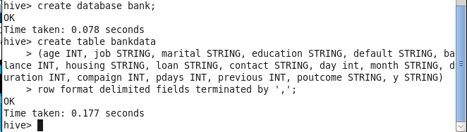

1. understand the schema, LOAD file in to table

command :-

Hive>LOAD DATA LOCAL INPATH 'bankfull.csv' INTO TABLE bankdata;

Hive>describe bank;

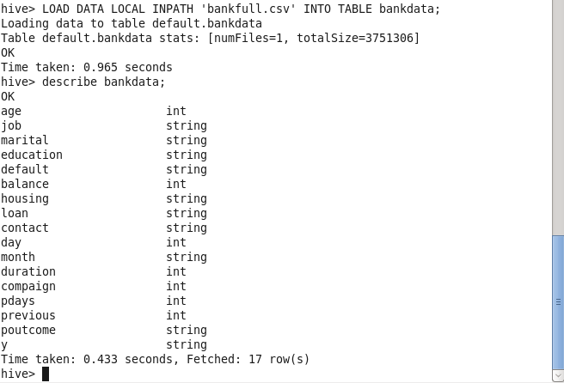

1. with the use of AND Logical operator get the records who has age greater than 25 and married.

Command :-

select \* from bankdata where age>25 and marital='married' limit 50;

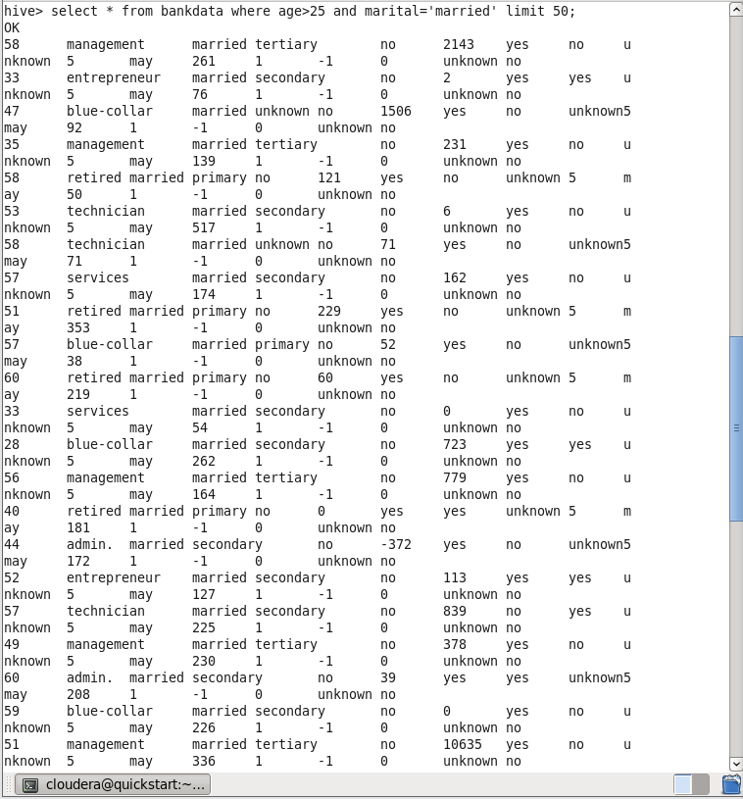

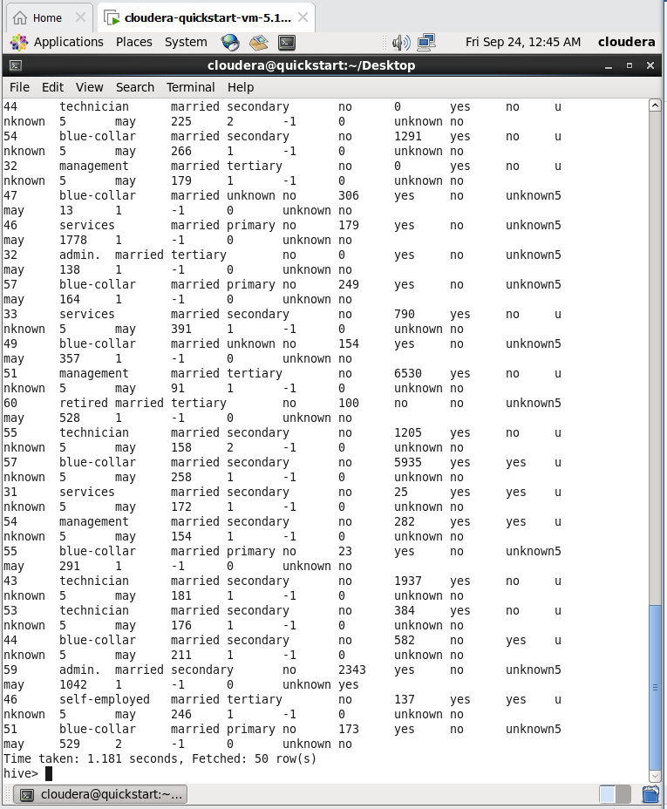

4. Who has not subscribed to a term deposit (column: y)

Command:-

Hive> select \* from bank where y='no' limit 50;

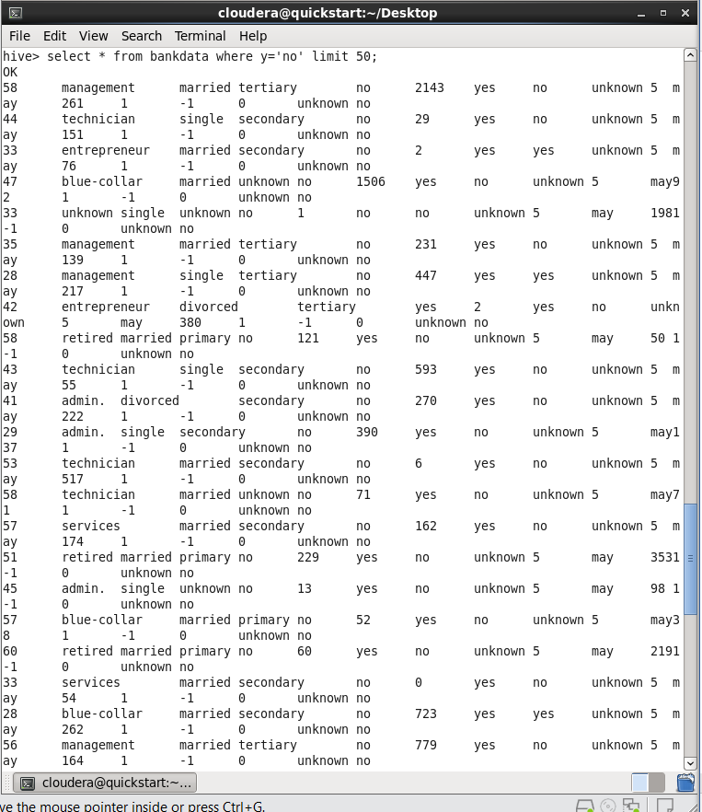

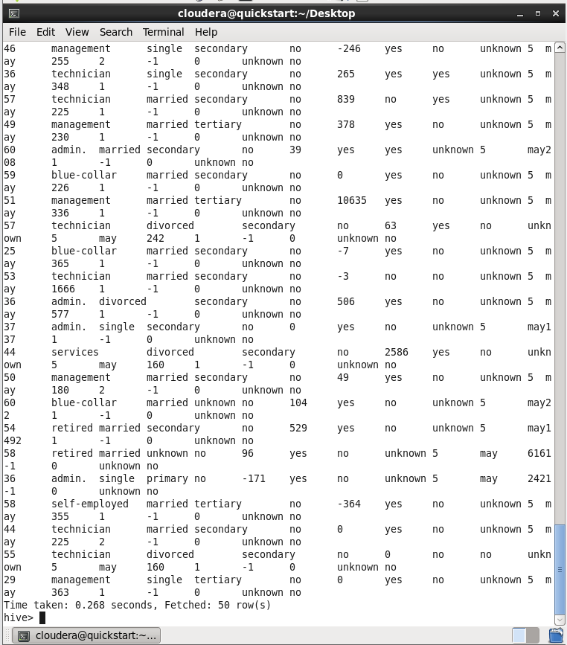

5. List the age group of the people who have subscribed to a term deposit.

Command:-

Hive> select distinct(age) from bank where y='yes' limit 50;

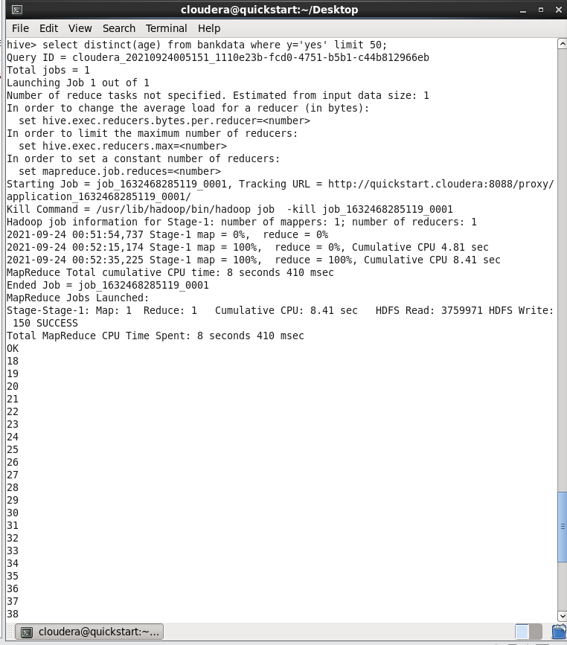

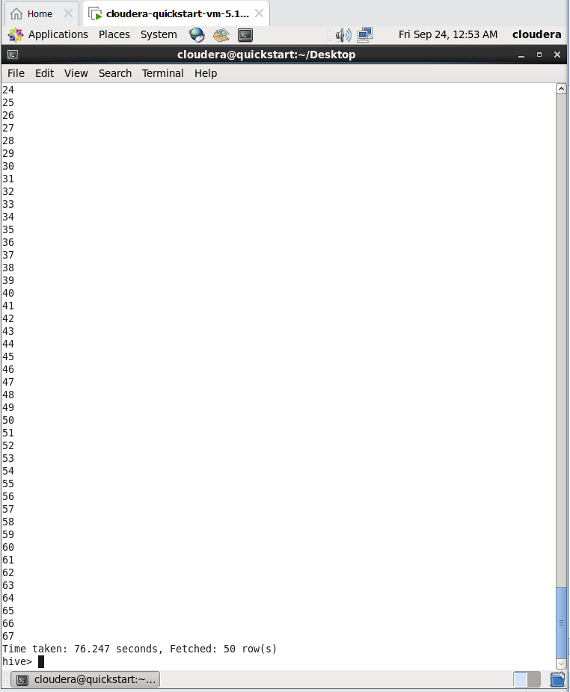

6. Find the job status for the people who has been contacted more than once.

Command:-

Hive> select job from bank where compaign>1 limit 50;

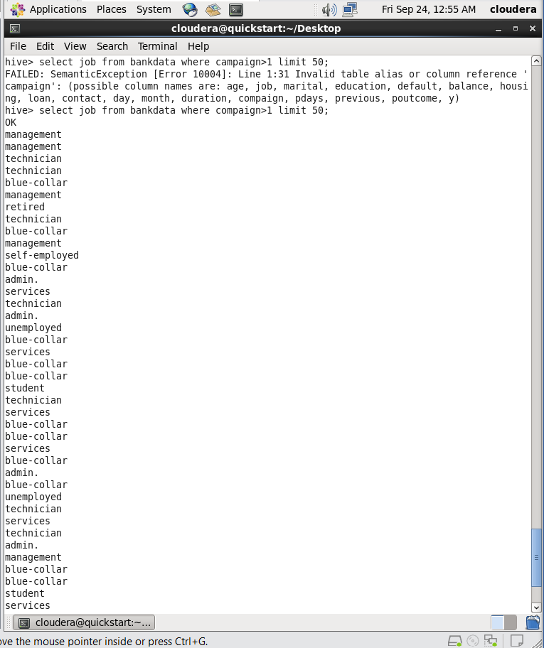

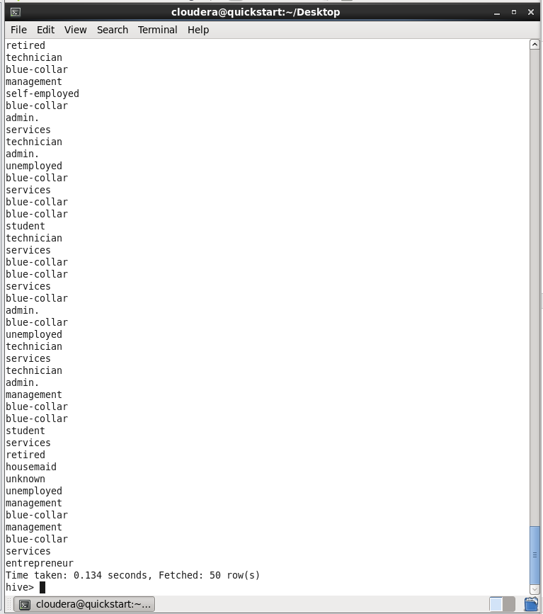

7. Find the number of single people contacted and sort by age.

Command :-

Hive> select age,count(\*) from bankdata where marital=’single’ group by age LIMIT 10;

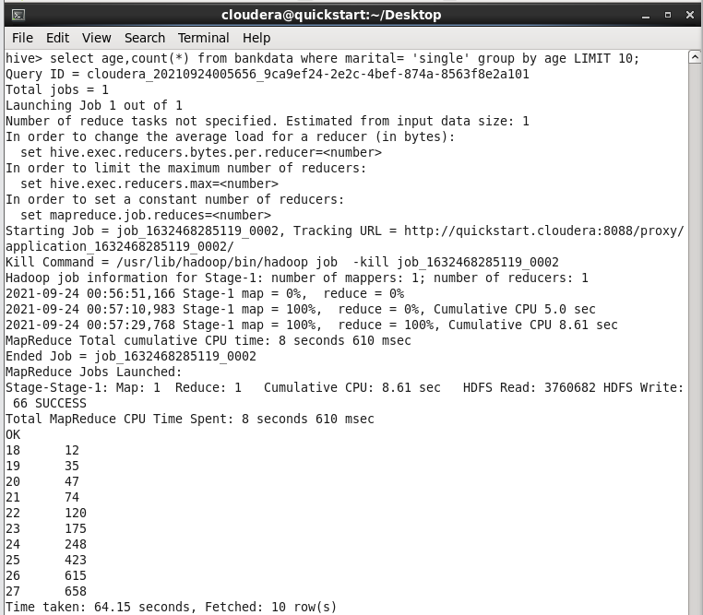

8. Calculate the average balance in the month of June and July.

Command:-

Hive> select AVG(balance) from bankdata where month=’jun’;

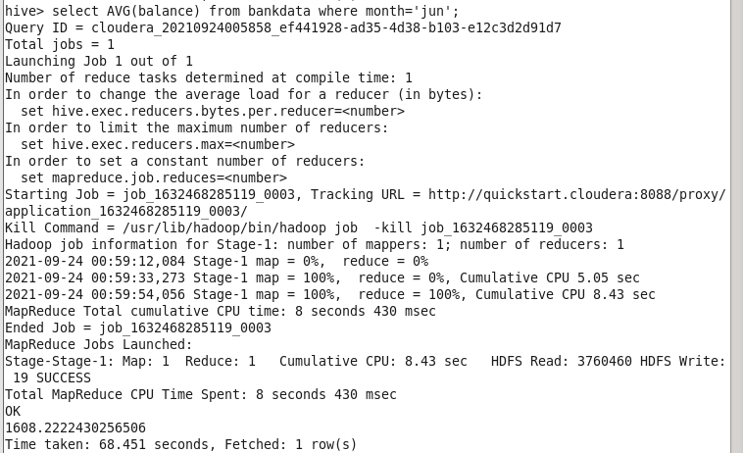

Hive> select AVG(balance) from bankdata where month=’jul’;

